**Creating a build pipeline**

1. Navigate to your team project on Azure DevOps.
2. Navigate to **Pipelines | Builds**.

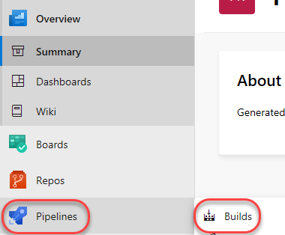

1. Select **New | New pipeline** to create a new build pipeline.

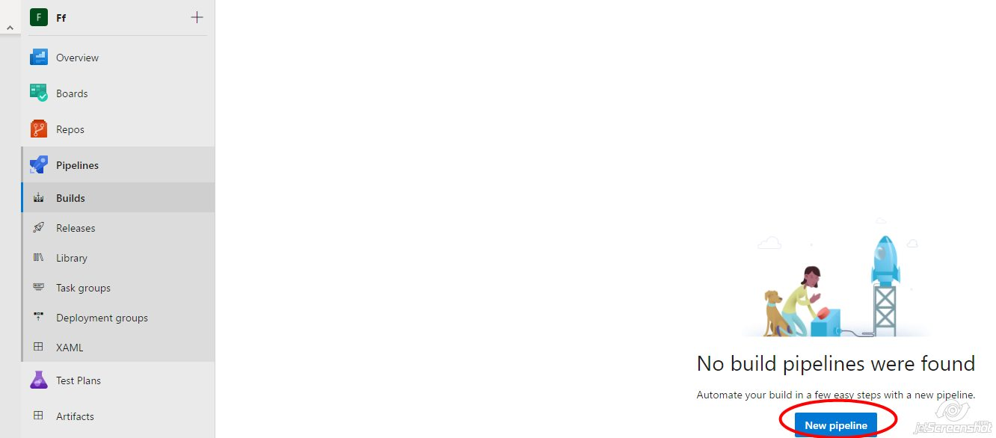

1. The first thing you’ll need to do is to configure the source repository. Every major platform is available, but the default options are all we need here. This build will use the **master** branch of the **Ff** repo. Leave the defaults and click **Continue**.

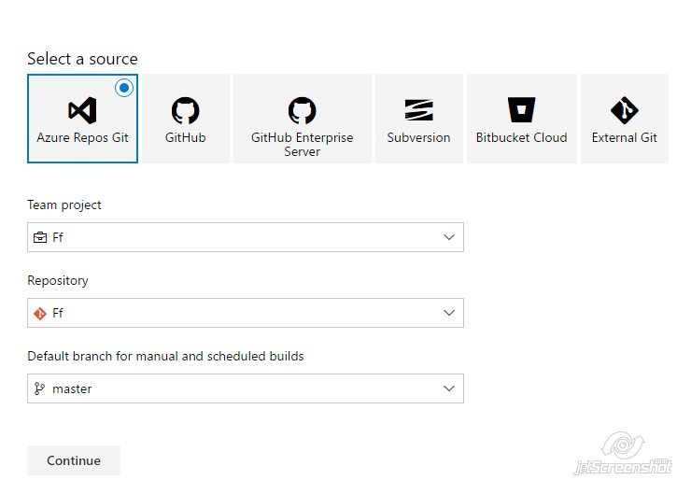

1. Locate the **ASP.NET** template and click **Apply** to apply this template to the build definition. Note that there are many options that should cover all of our mainstream scenarios. For our purposes here, we’ll just build the project using the baseline ASP.NET template.

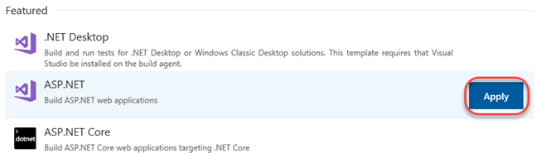

1. The process for this build pipeline is easy to follow. After getting the source, Azure DevOps will use NuGet to restore any dependent packages. Then, the project will be built and tested. The results will then be published to the configured target.

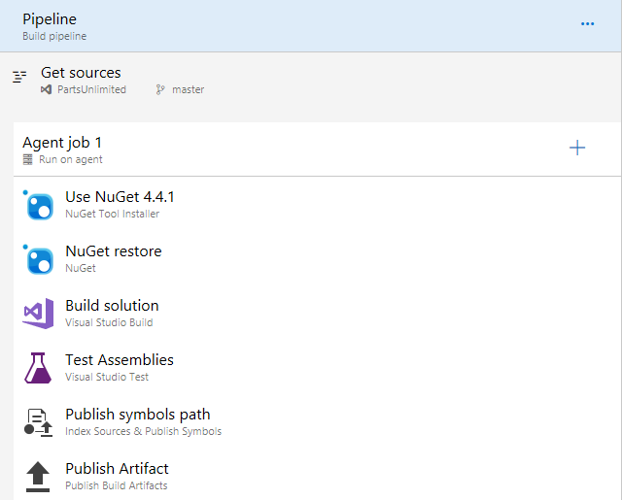

1. Select the **Variables** tab. Here you can configure special parameters to be used during the build, such as the configuration or platform.

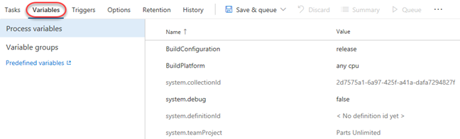

1. Select the **Triggers** tab. These triggers enable you to automatically invoke builds on a schedule, when another build completes, or when changes are made to the source. Check **Enable continuous integration** so that this build will get invoked whenever source changes are committed.

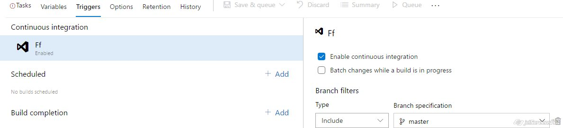

1. Select the **Options** tab. This section includes a wide variety of options related to the build workflow. Note that you’ll generally configure options for specific build tasks on the configuration views of the tasks themselves.

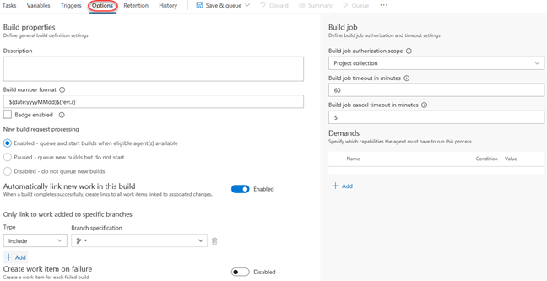

1. Select the **Retention** tab. This is where you configure which builds are retained and for how long.

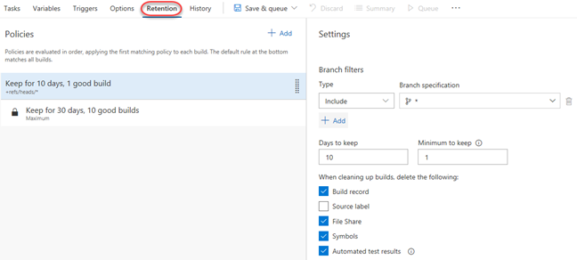

1. Select the **History** tab. There’s nothing here yet, but it will show a history of changes you make to the build definition.



1. Select **Save & Queue | Save & Queue** to save and queue a new build.

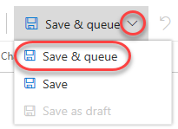

1. Accept the default options by clicking **Save & queue**.

